Elastic container service (ECS)
- Setup a highly available ecs cluster with load balancer and dynamic port mapping.
NOTE:
Your cluster should maintain atleast 6 tasks at any point of time and should be highly availble across multiple AZ's.
Use the below image from deployment:
sabair0509/hiring-app:works

First Create IAM Roles
ECS Instance Role
IAM → Create Role → AWS Service → EC2
Give permissions Attach: AmazonEC2ContainerServiceforEC2Role
Name: ecsrole

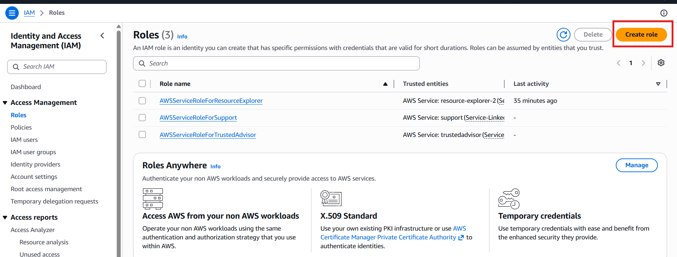
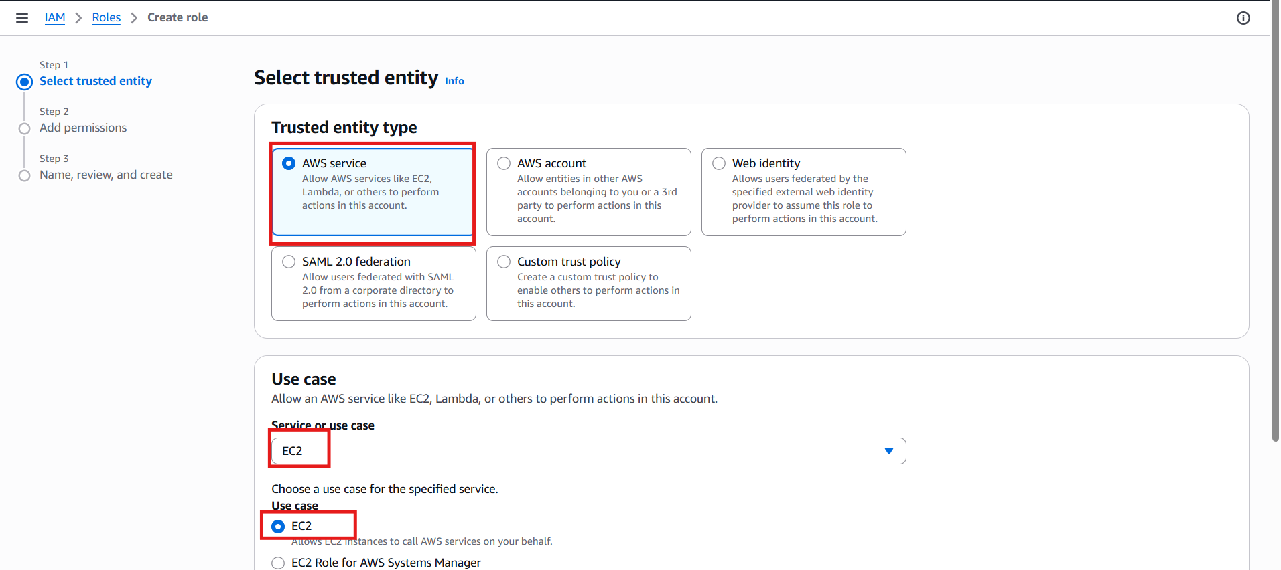
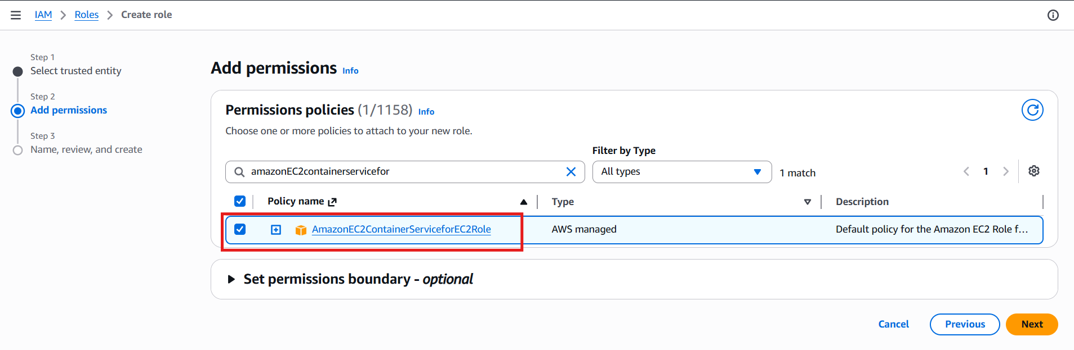
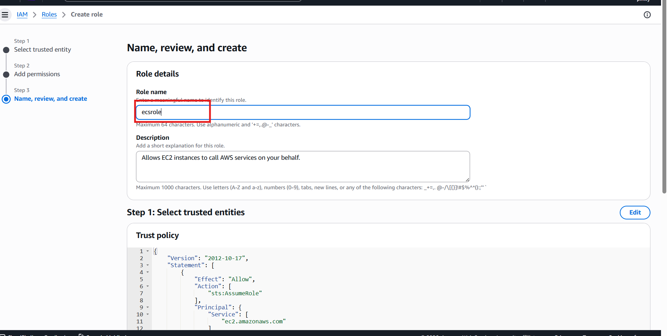
Create ECS Cluster (EC2)
ECS → Create Cluster → EC2 Instances
Cluster name: hiring-app-cluster
Instance type: t3.large
Min: 2 instances
Max: 6
Instance role: ecsrole
EBS Volume:30
Auto assing public ip:trun on
Ensure instances launch in multiple AZs.
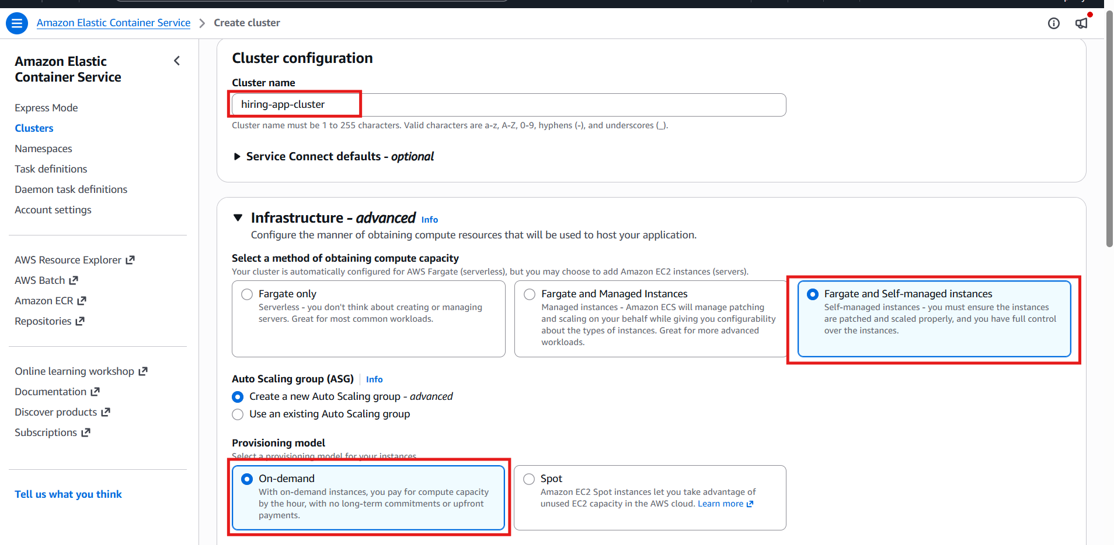
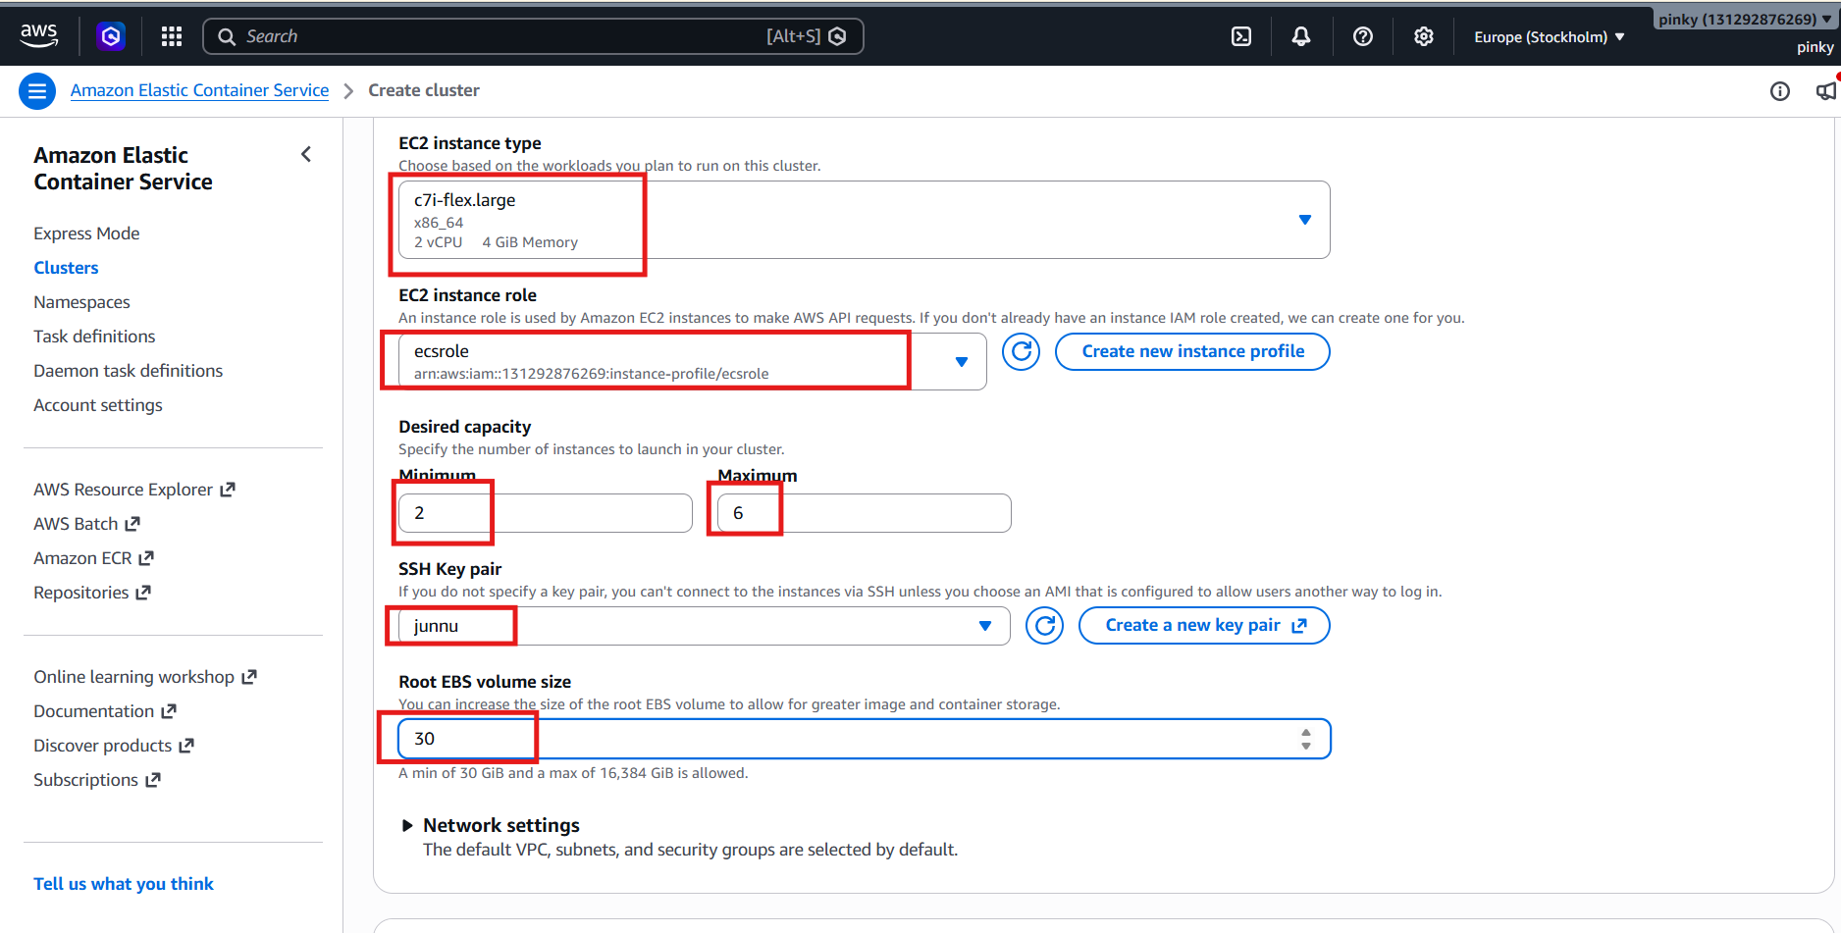
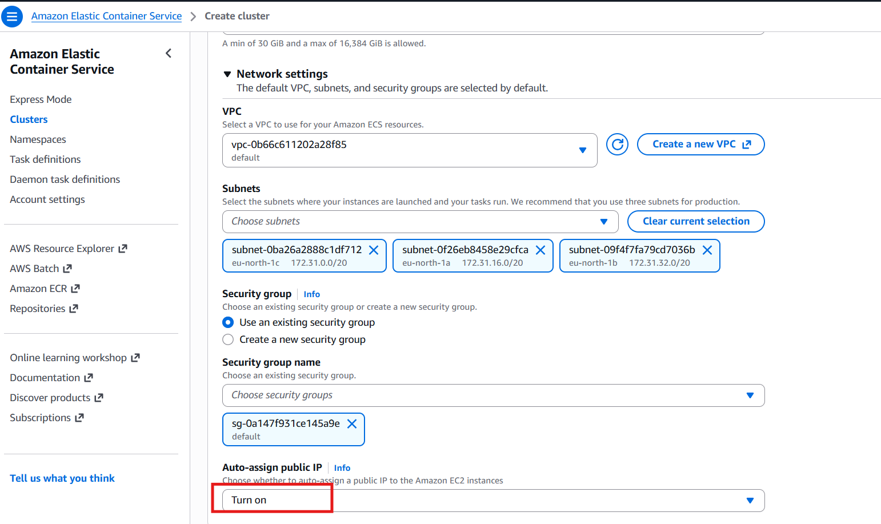
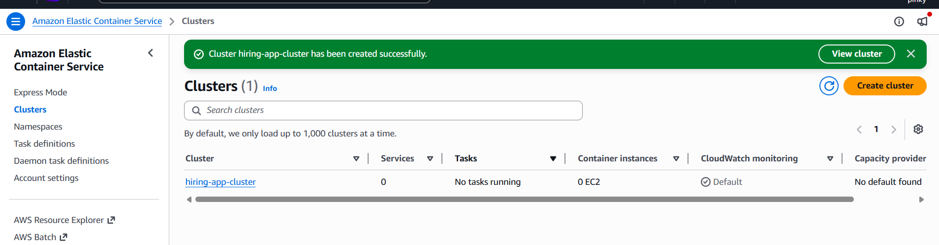
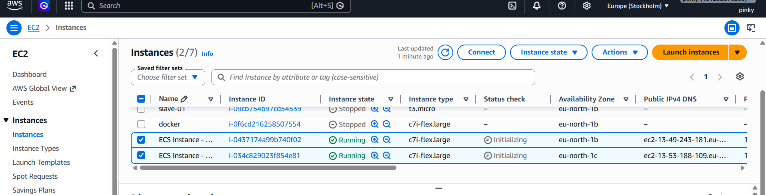

Now go to iam role to give permission
Aws serviceelastic container service elastic container service taskattach the role give the role namesave
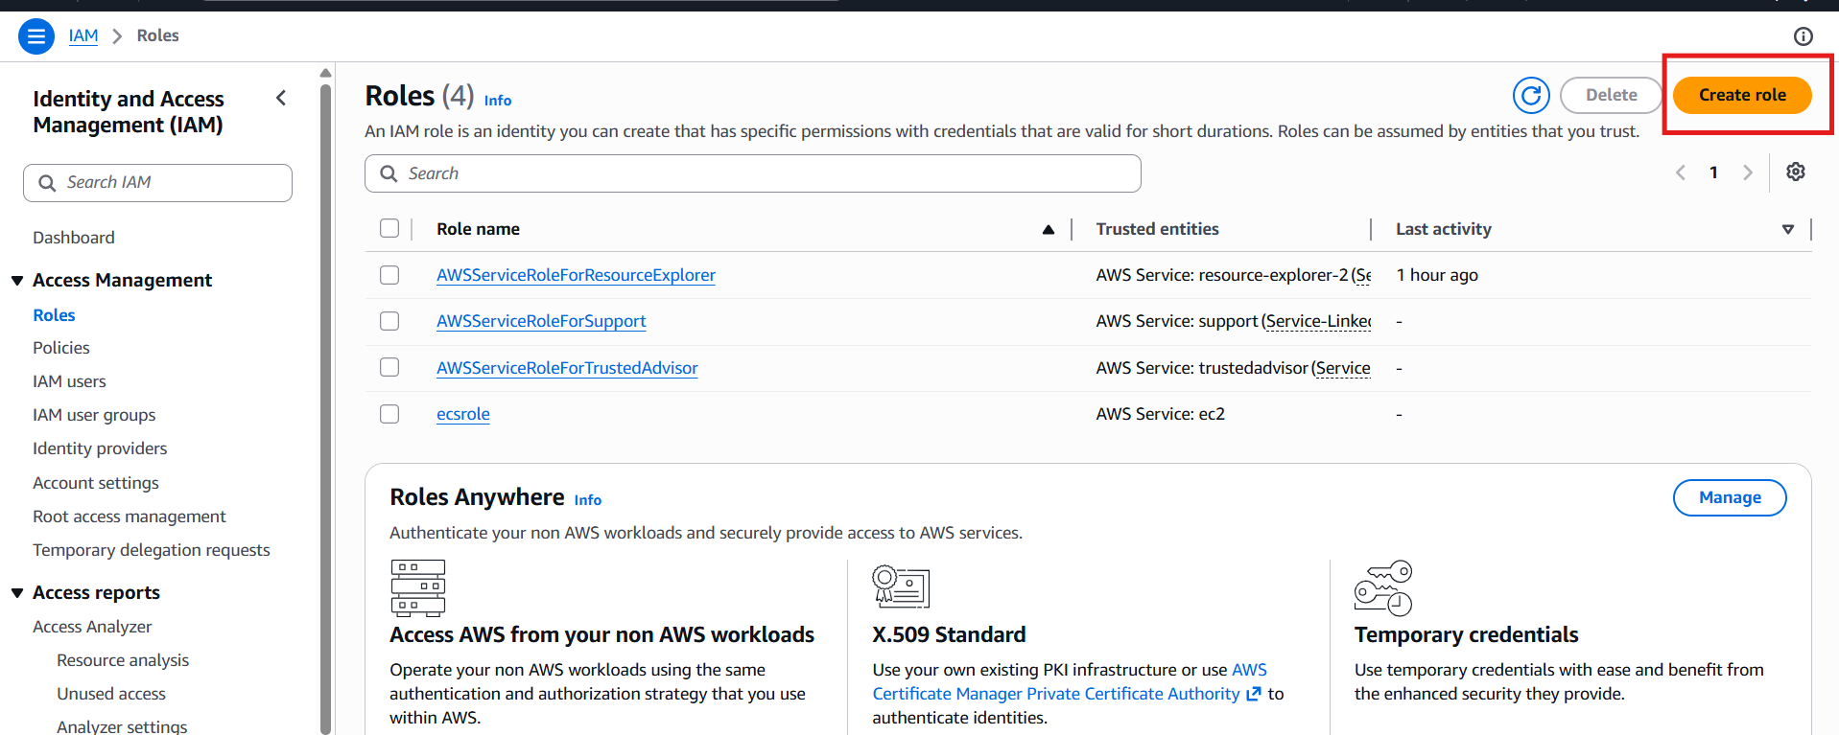
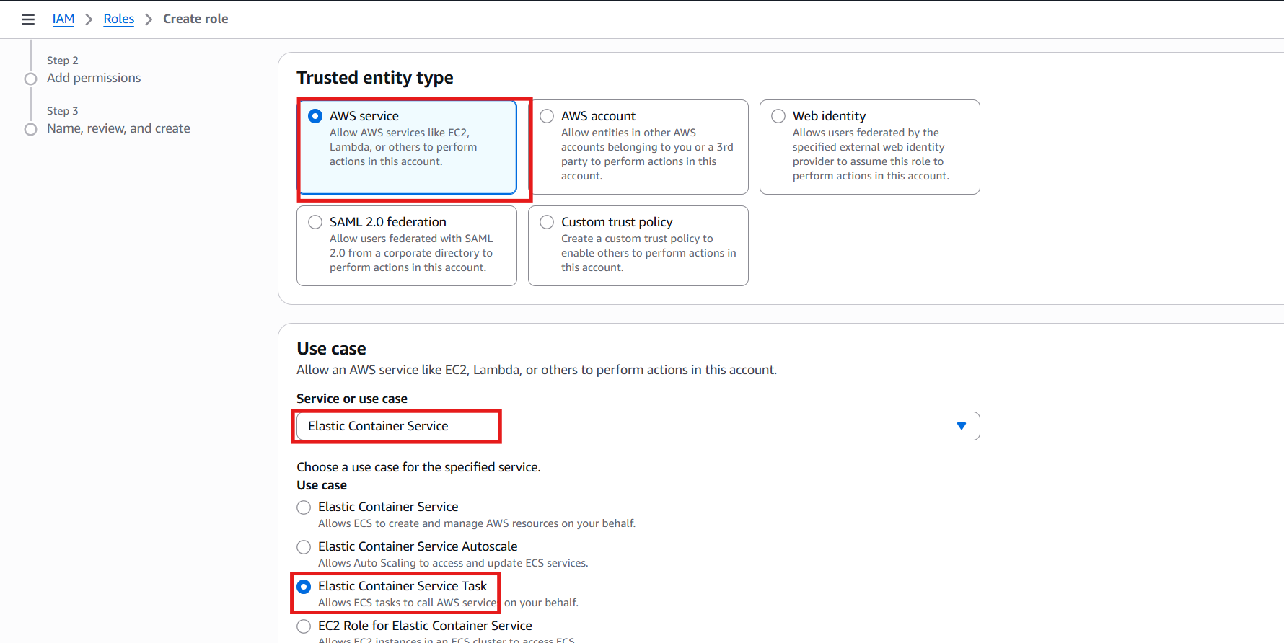
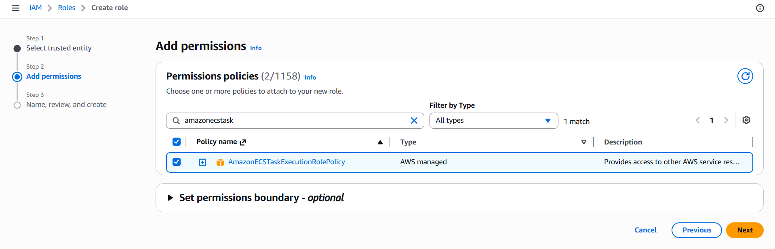
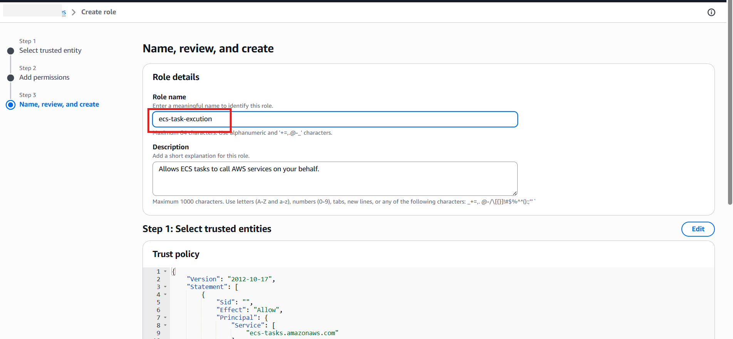
Create Task Definition
ECS → Task Definitions → Create
Family: hiring-app-task-definition
Launch type: EC2
Network mode: bridge
CPU: 0.5 vCPU
Memory: 1GB
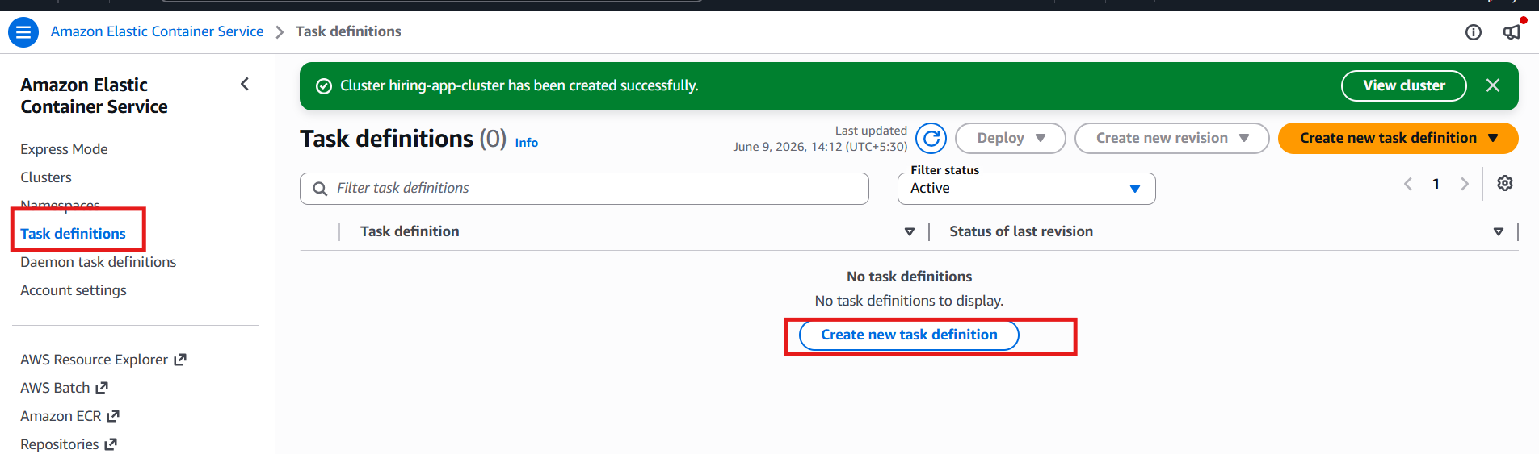
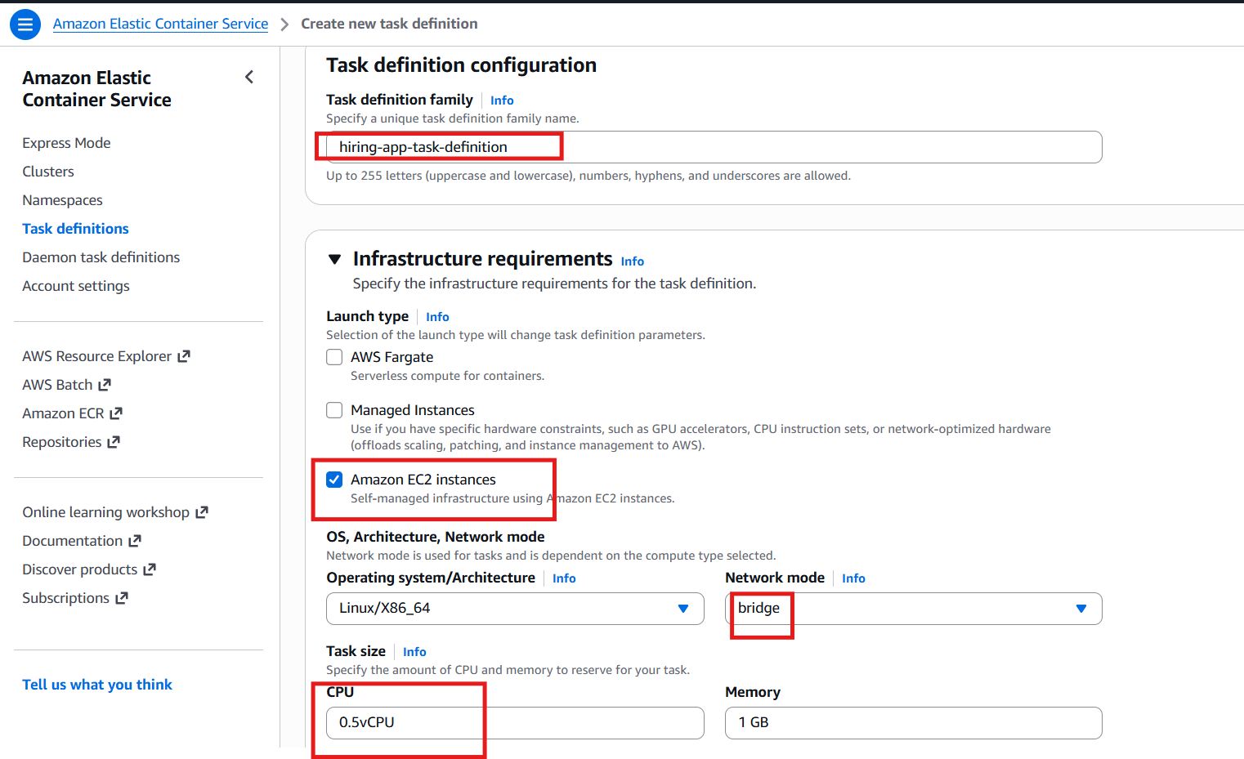
Container
Name: hiring-app
Image: sabair0509/hiring-app:works
Container port: 8080
Host port: 0 (Dynamic port mapping)

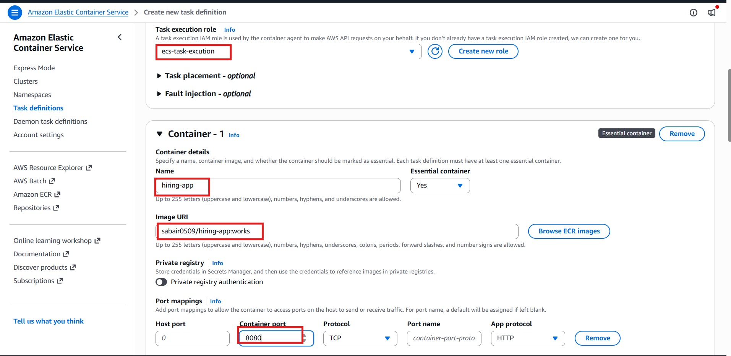
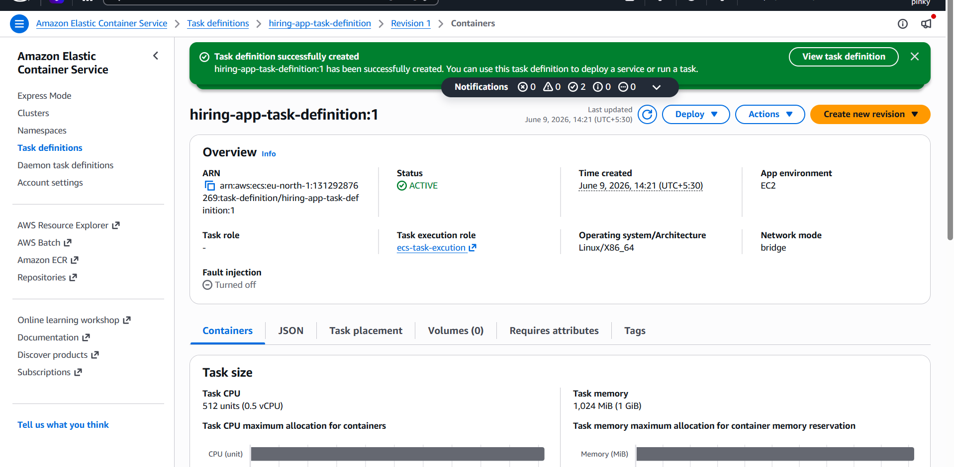
Create Target Group
EC2 → Target Groups → Create
Type: Instances
Protocol: HTTP
Port: 80
Health check path: /
Success codes: 200-499
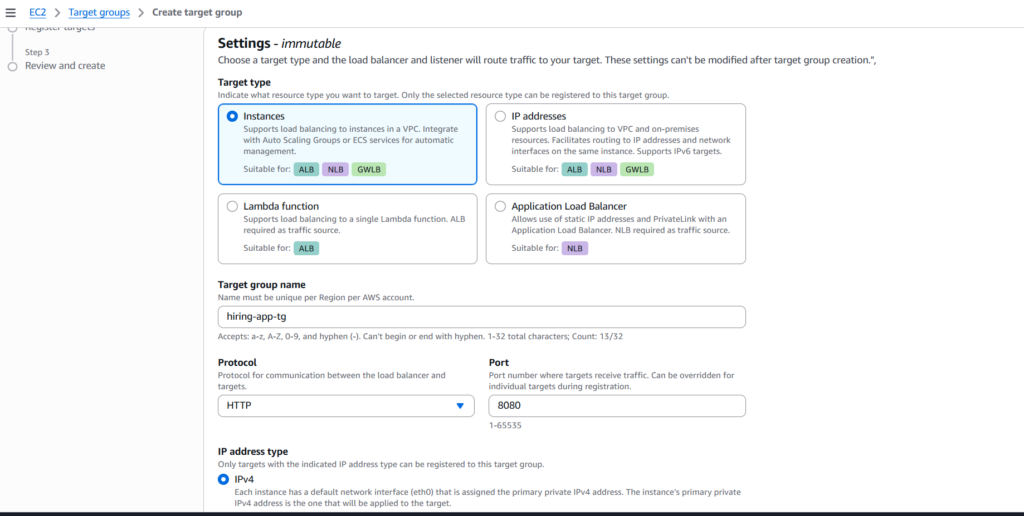
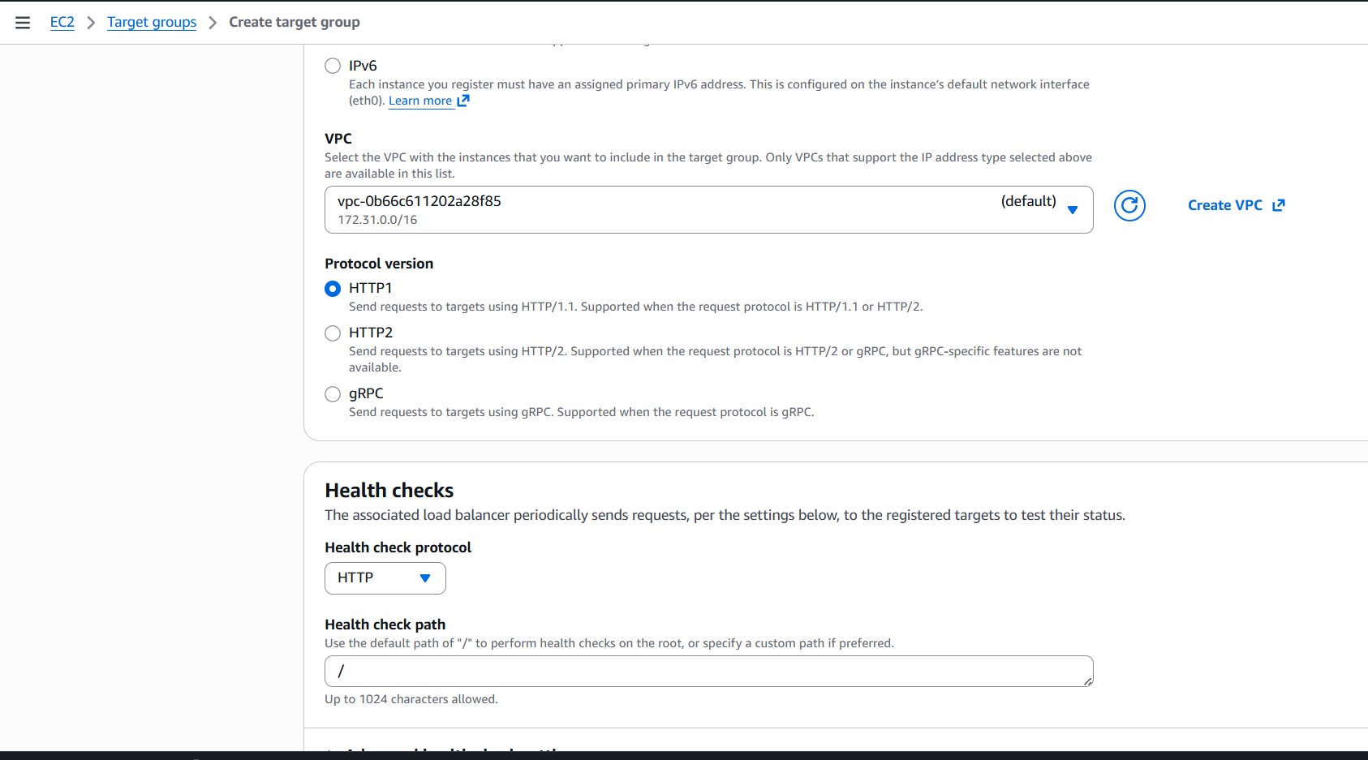
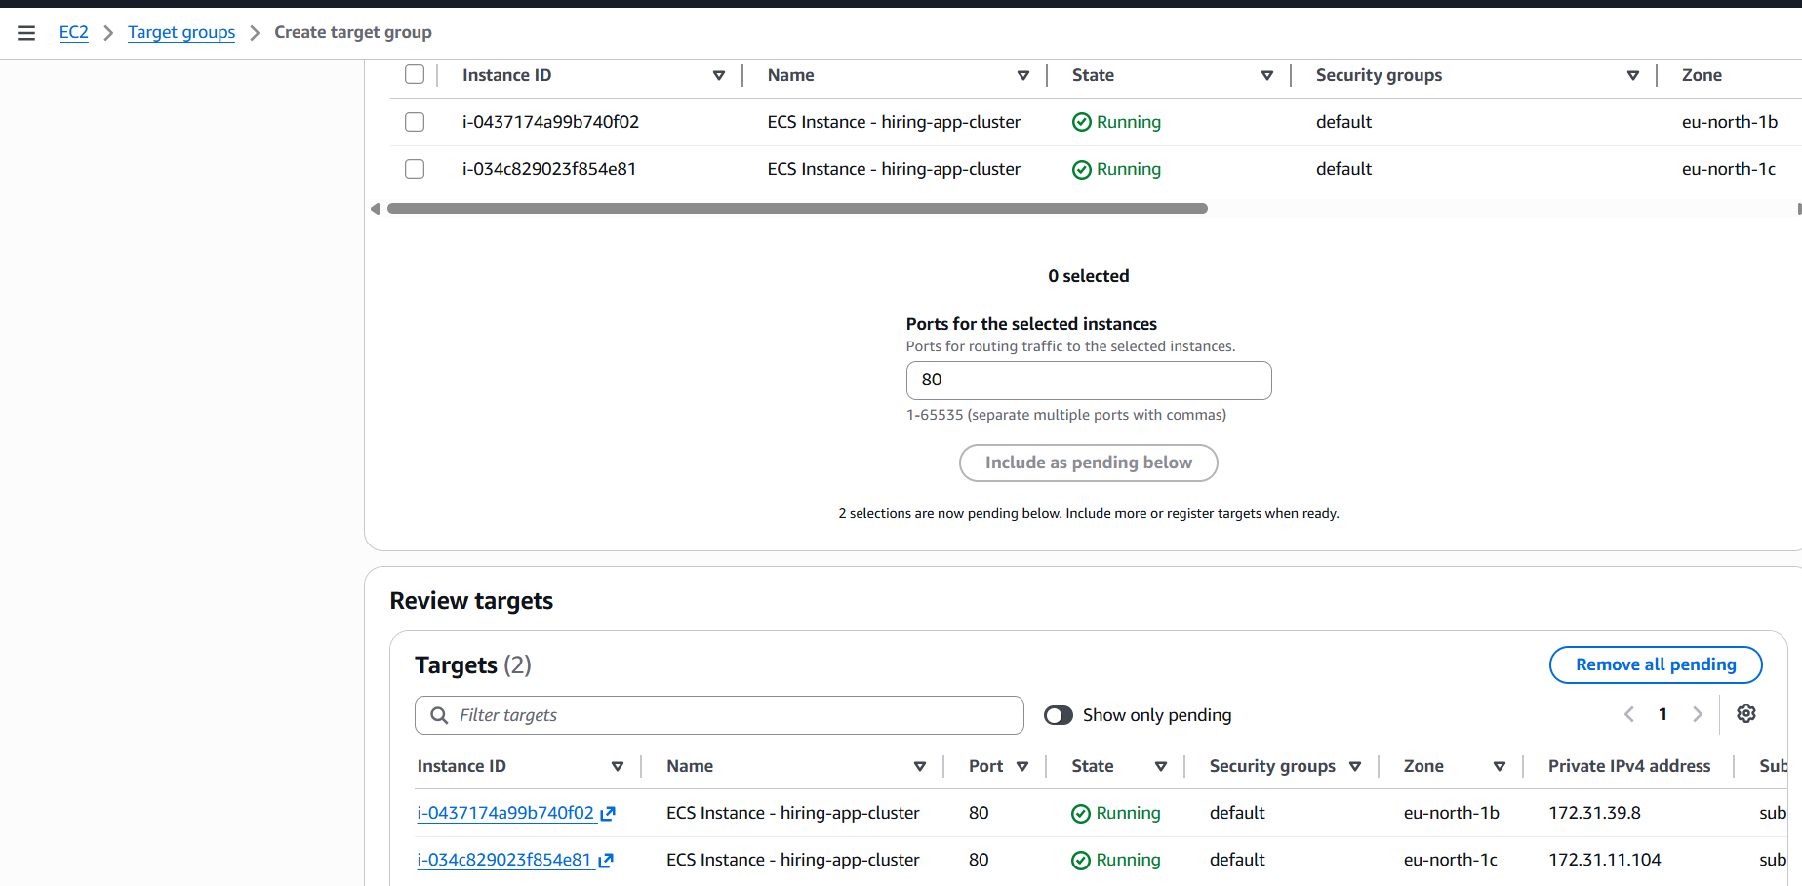
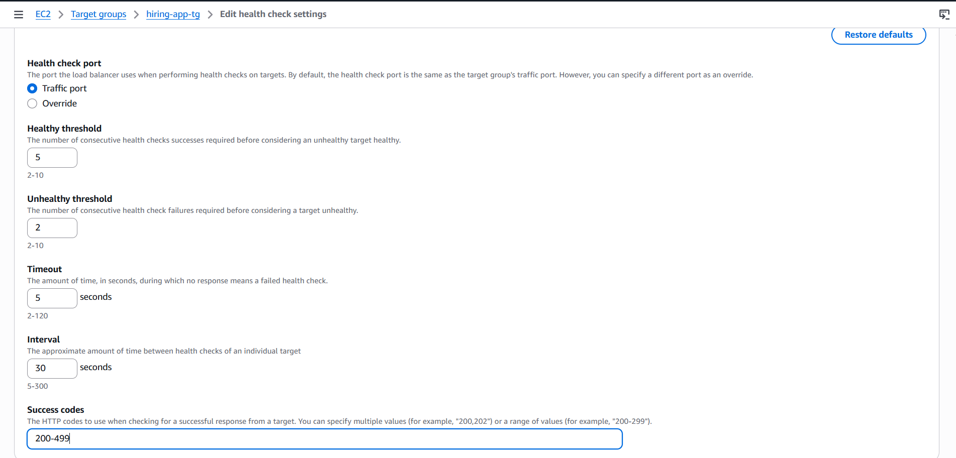
create Application Load Balancer
EC2 → Load Balancers → Create ALB
Name: hiring-alb
Scheme: Internet-facing
Select default vpc
Select 2 subnets (Multi-AZ)
Listener: HTTP 80
Attach Forward to target group
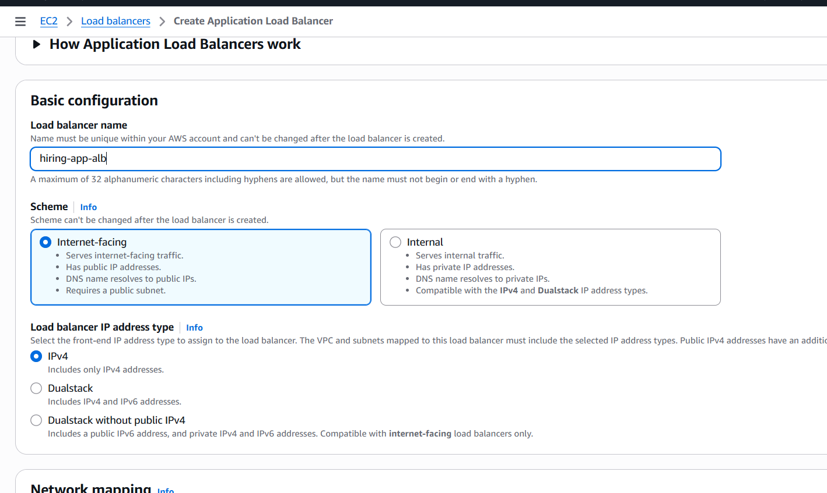
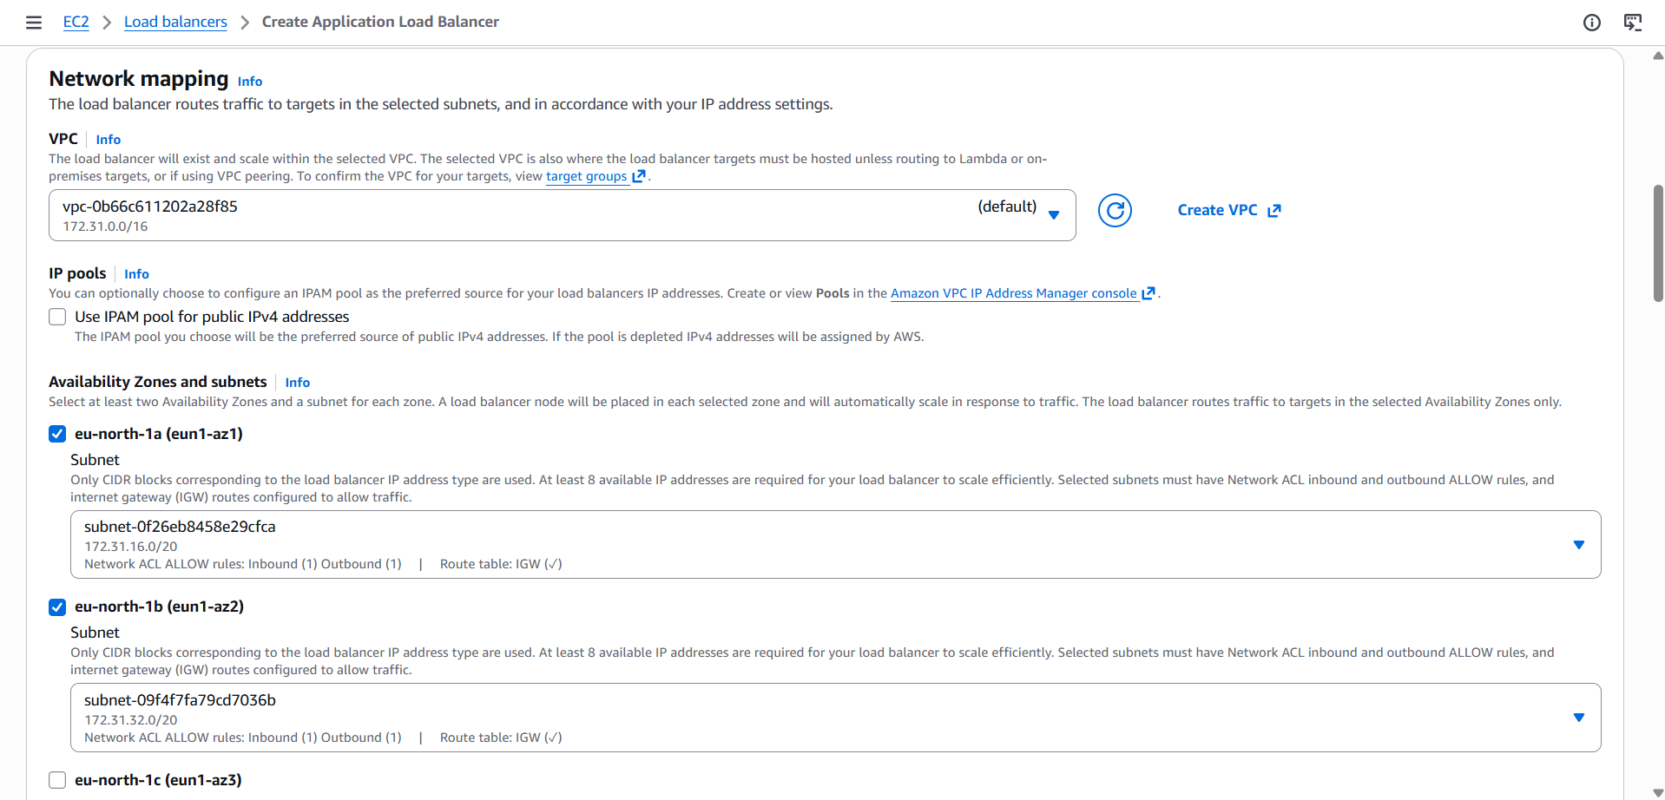
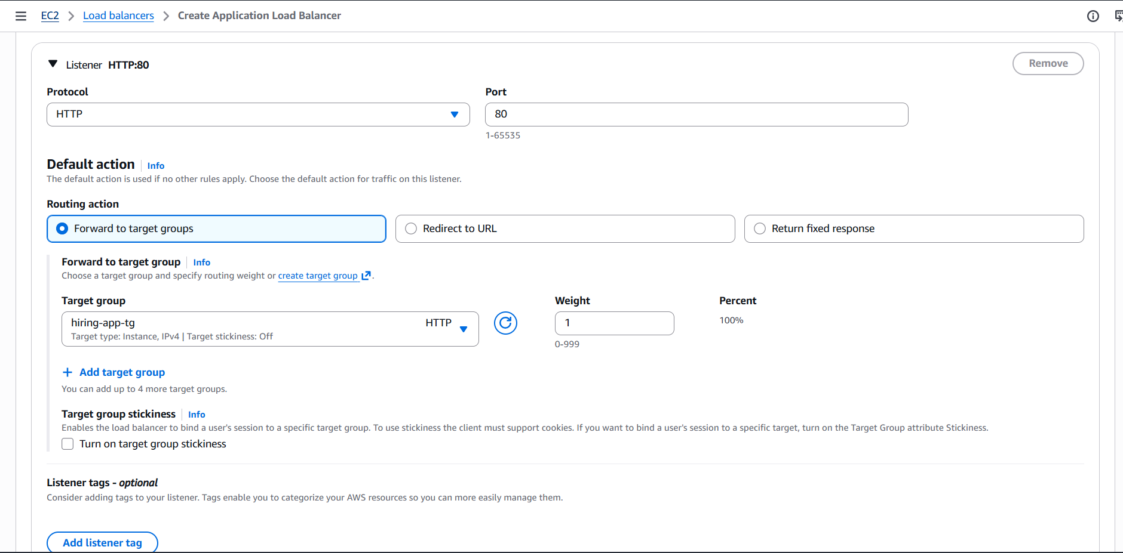

Go to ecsclusterscreate serviceenvinornmentselect launch typeec2

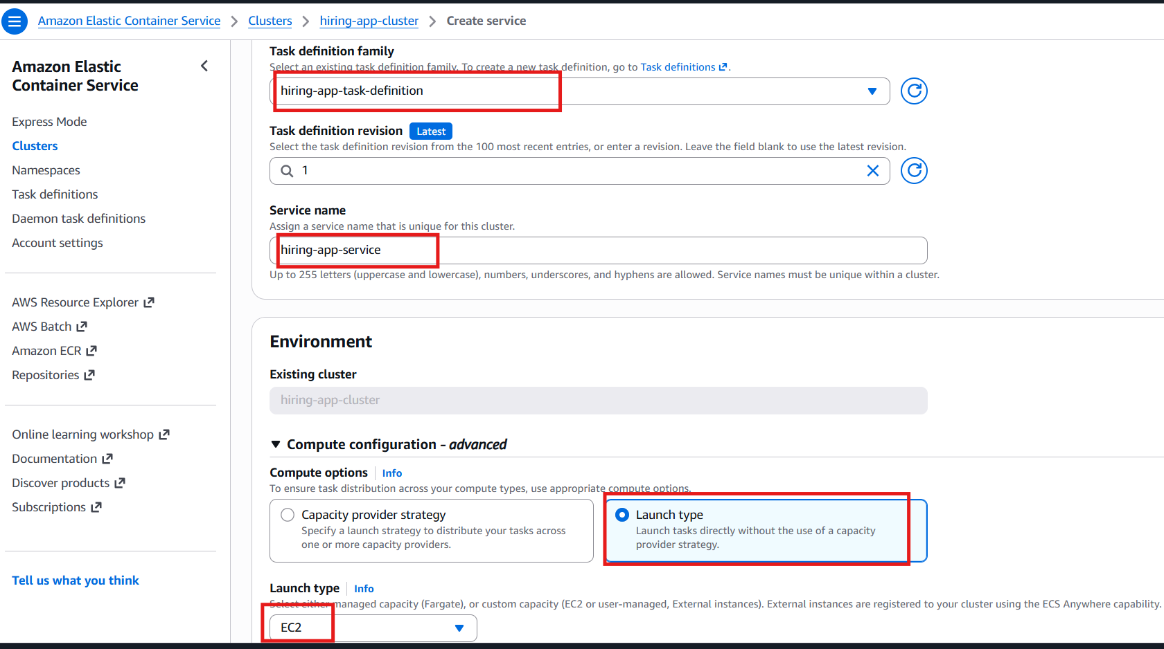
Deployment configuration replicadesired task 6
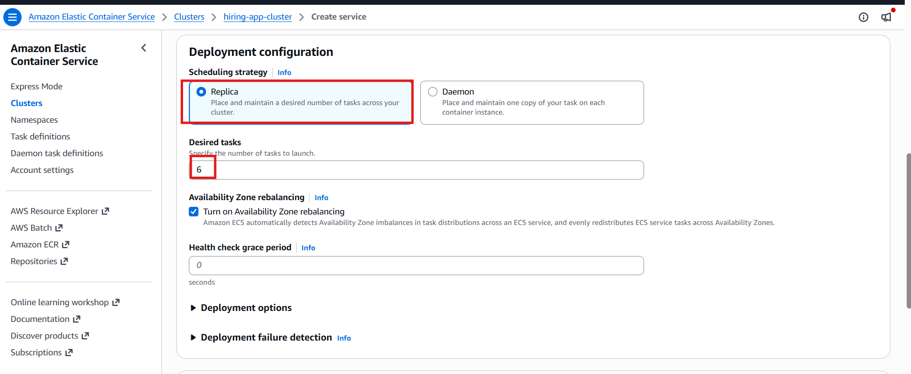
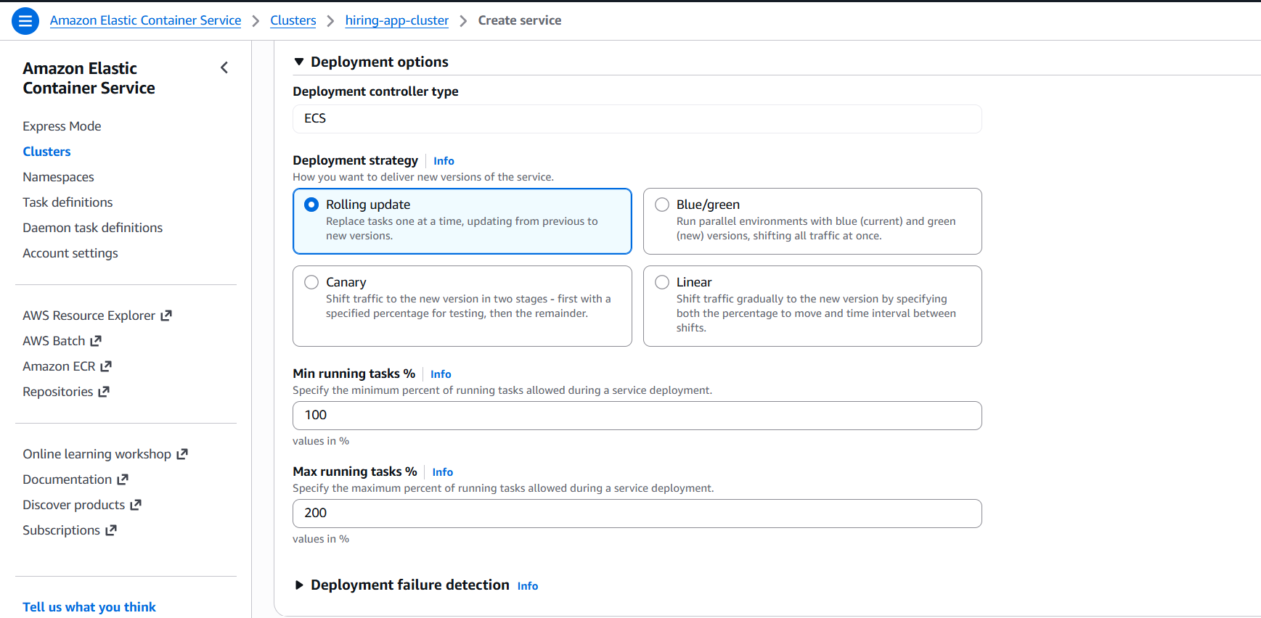
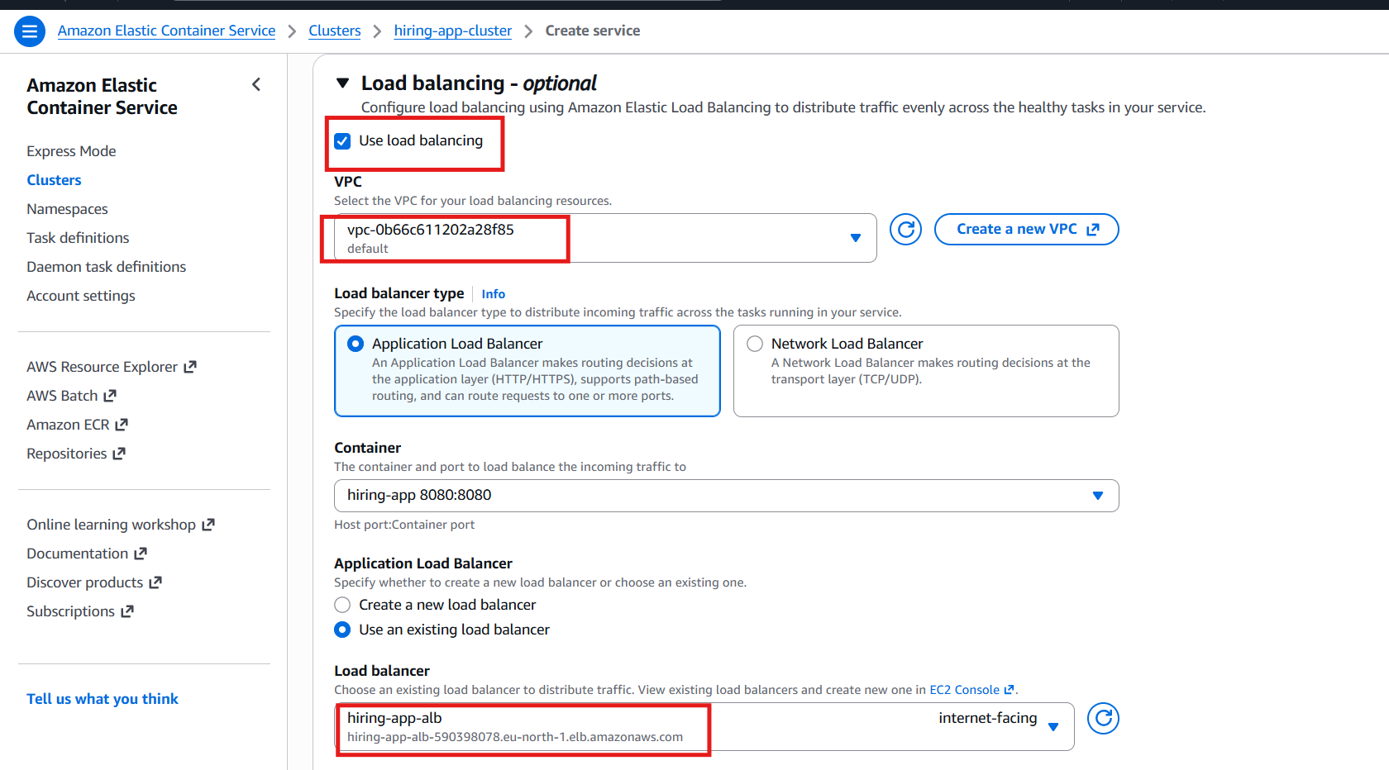
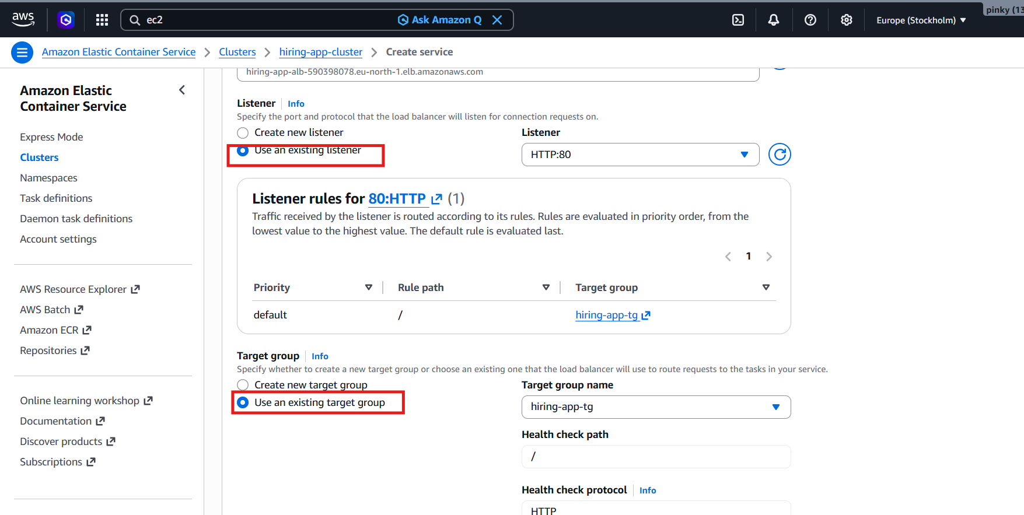
Enable Auto Scaling
Minimum tasks: 6
Maximum tasks: 12
Policy: Target Tracking
Metric: ECSServiceAverageCPUUtilization
Target: 70%
Result
6 tasks always running
Tasks distributed across multiple AZs
ALB distributes traffic
Dynamic port mapping enabled
Highly available architecture achieved

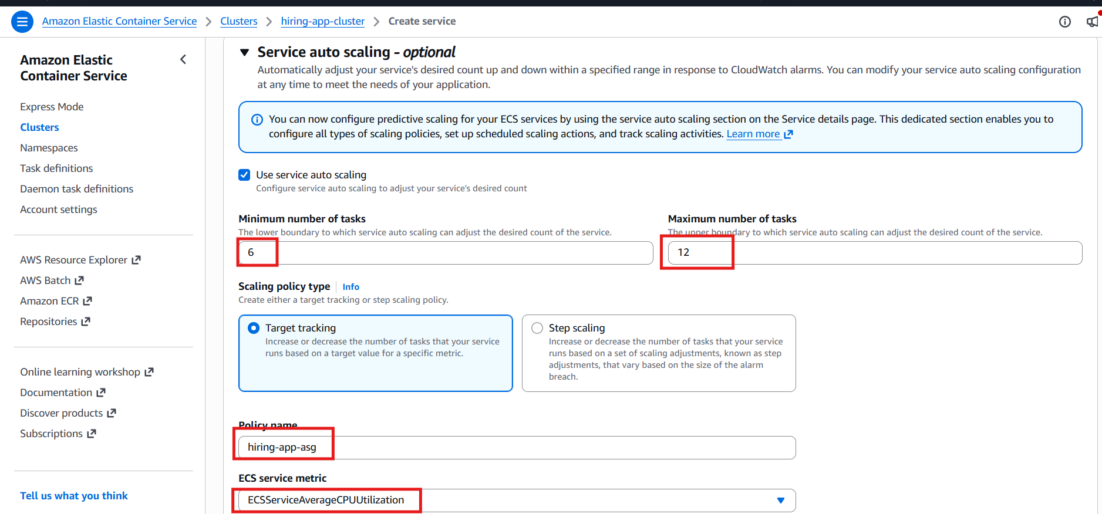
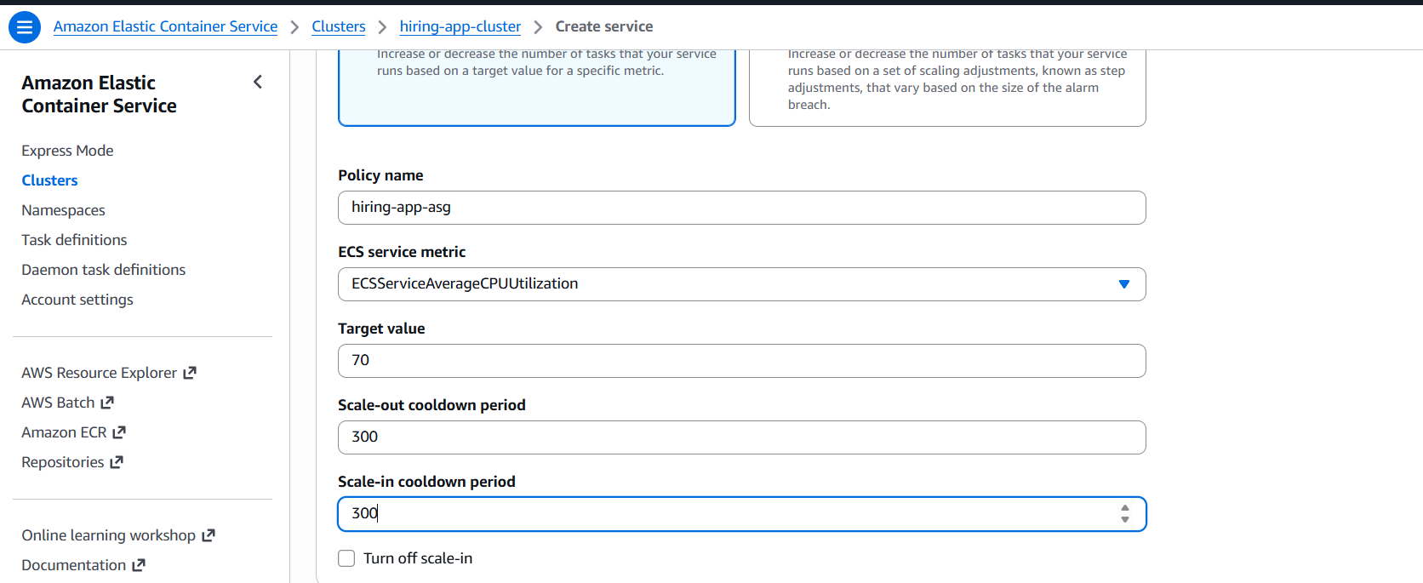
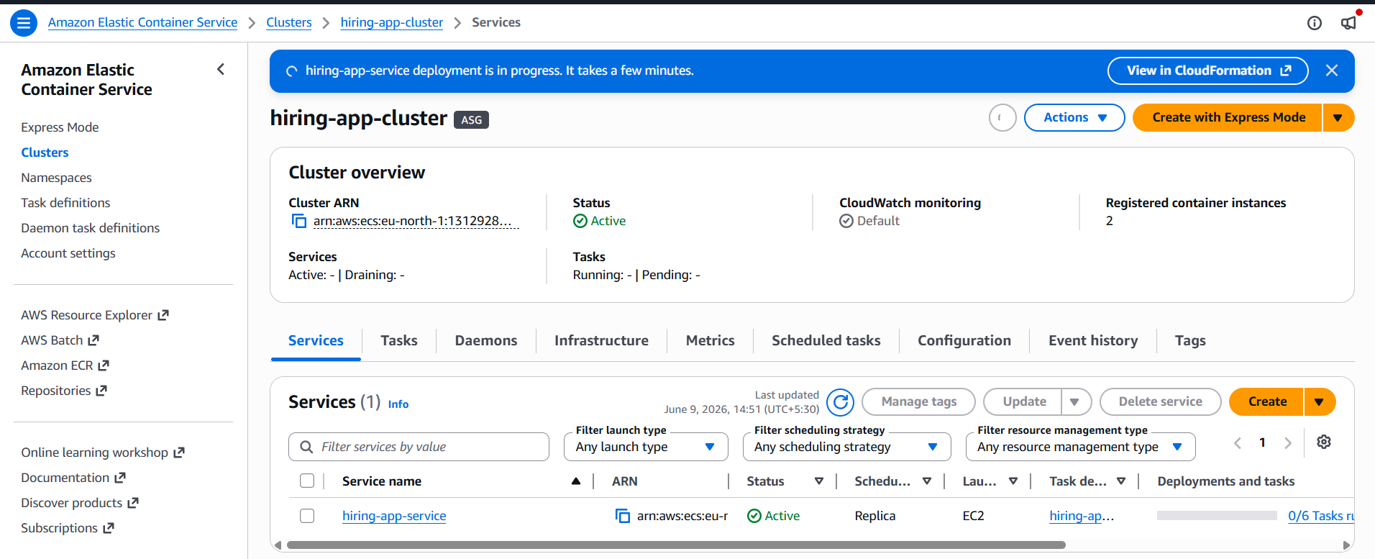

Go to load balancer Copy the dns name
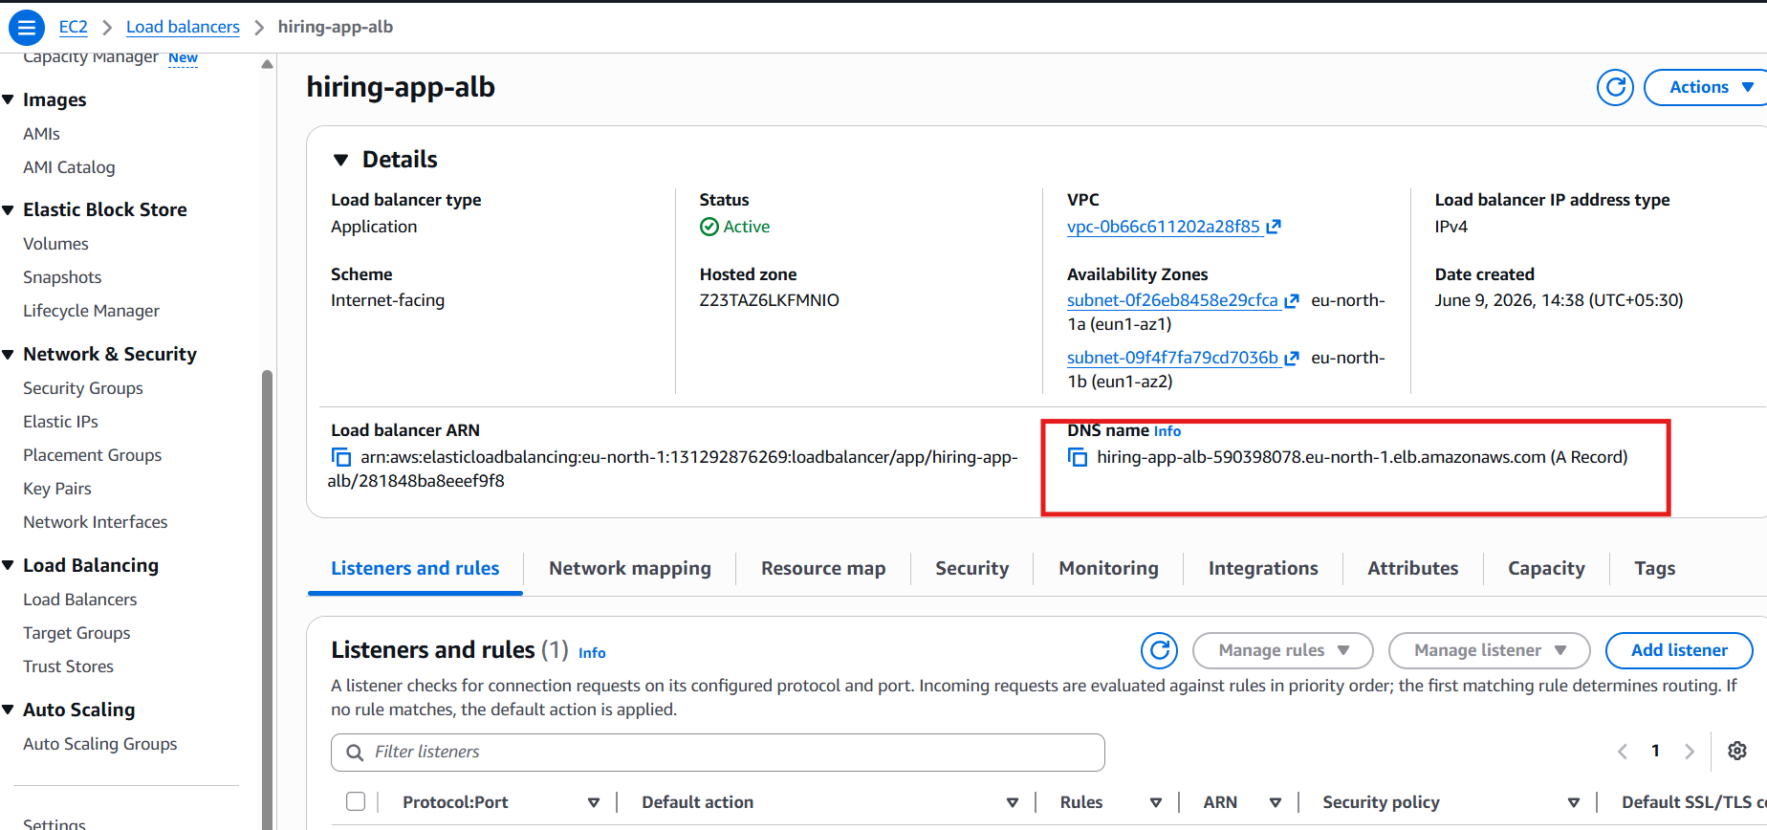
Verify the browser


